Final Project Milestone #4

CIS 9440 - Data Warehousing for Analytics

Final Project Milestone 4

Group Number – 6, alone

Student(s) – Leandro Coimbra

1) List your final set of 5 KPI’s.

1. The decrease of enrollment in NYC schools per COVID years
2. Reallocation of budget during COVID years
3. Education budget per year
4. Poverty level compared to school graduation
5. Economic need and dropout rate correlation during COVID years

2) Short description of Visualization that will be used for each KPI. Why will you use that type of visualization?

The purpose to use thus type of illustration is to show the pre vs post covid numbers in relation of education budget versus student retention in the New York City schools. I have position the charts in a manner where the user can analyze the data and come to the conclusion that the reallocation of education budget will cause lower graduation rates and more dropouts for the ones that need the most. The budget and expenses are position towards the right and together for easier comparison. All charts are the same color expect the enrollment as I wanted to make it the main point of my dashboard.

* The top left line chart is the decrease with new enrollment for student from 9-12 in new York city based on the year 2020 to 2021
* The Budget distribution on the top right is how the budget is being distributed in the current year in the New York City schools.
* The education budget bar chart illustrate how much of the budget was lost reallocated since the last year
* The area Chart shows the correlation of poverty level and school graduation rate are both on the decline since the budget was reallocated
* The economic need and dropout rate can be seen going hand to hand in the column chart.

3) Paste a picture of your BI Application Wireframe (hand drawn image, google draw, any other format).

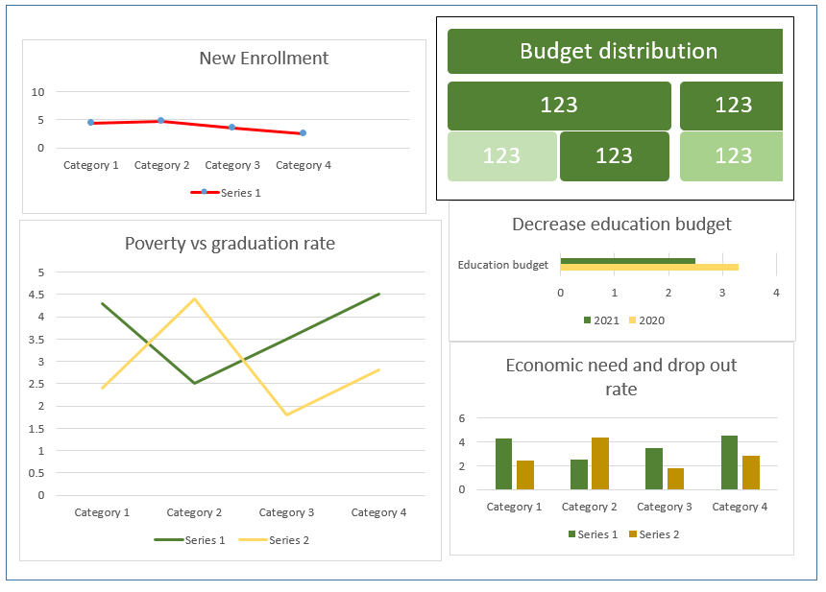

4) Link to your Tableau Public dashboard. (ensure this link works!)

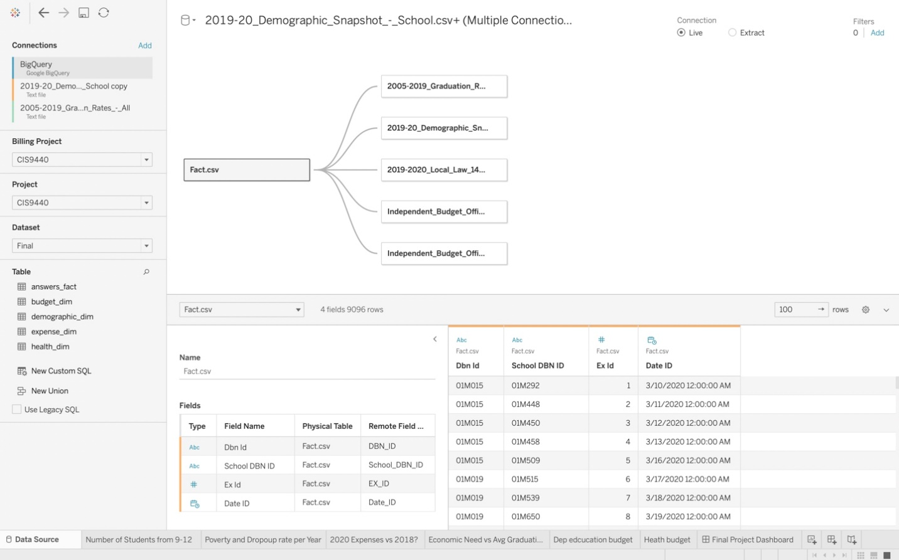

(Optional, 5) Any notes for the professor about your visualization or template submission.

Tableau public link: [https://public.tableau.com/views/LC_FinalDashboard/FinalProjectDashboard?:language=en-US&publish=yes&:display_count=n&:origin=viz_share_link](https://nam04.safelinks.protection.outlook.com/?url=https%3A%2F%2Fpublic.tableau.com%2Fviews%2FLC_FinalDashboard%2FFinalProjectDashboard%3F%3Alanguage%3Den-US%26publish%3Dyes%26%3Adisplay_count%3Dn%26%3Aorigin%3Dviz_share_link&data=04%7C01%7Cleandro.coimbra%40hofstra.edu%7C8b6d63f19af040b57cf208d9b4fba5dc%7Ce32fc43d7c6246d9b49fcd53ba8d9424%7C0%7C0%7C637739815176740530%7CUnknown%7CTWFpbGZsb3d8eyJWIjoiMC4wLjAwMDAiLCJQIjoiV2luMzIiLCJBTiI6Ik1haWwiLCJXVCI6Mn0%3D%7C3000&sdata=sboS3sCcubtP2ZvlGd4oRcv%2Btzw9kpUBbnbZCPuBm4s%3D&reserved=0)

